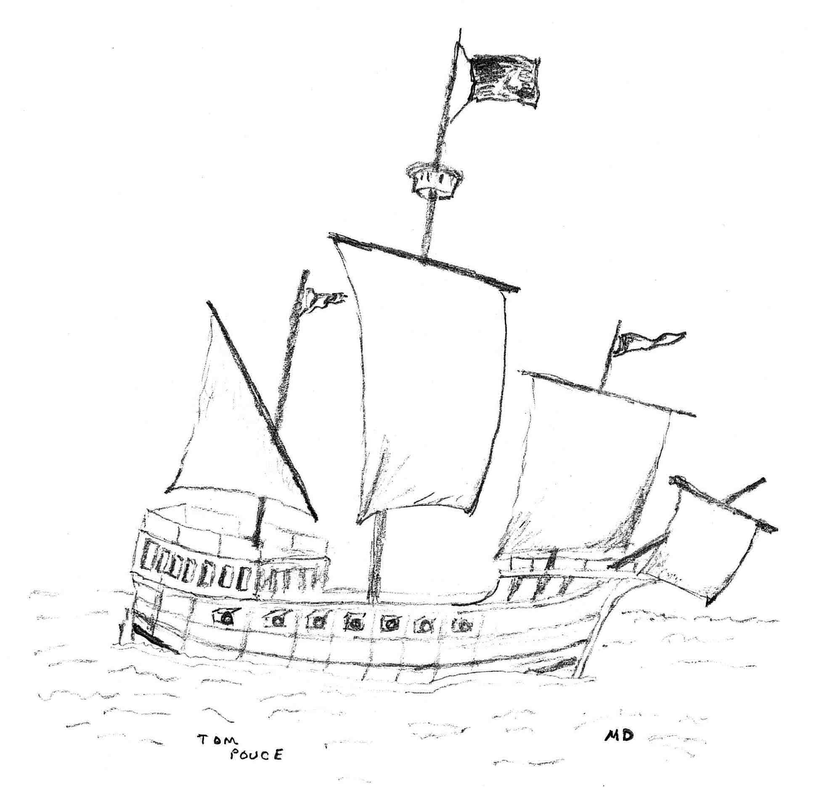
An build for speed fourteen 32 pound guns Corvette

Some History

Crimson Blade is the name of the ship build by, and the pirate crew recuited by the famous captain Cryxus, circa 2009.

Cryxus famous motto :
If everything I do is wrong, goddamn I do it right.

Having already build his ship and recruit an crew, tried to setup an alliance, to officially introduce in MagicDuel pirates. Wanting to set it up in Golemus, for Golemus is the only land having access to open see and able to provide an safe harbor for his ship. Storm Dock being an idea place.

Alliance mission statement: The Crimson Alliance will be a guild based out of Golemus, seeing as how that is the only landmass that is surrounded by water.
Our job is to help whoever we see fit, for whatever price seems good...we are neither good, bad, or neutral.

True his efforts Mur tooked notice and reward him with special gifts.
The most important gift, is hability to permently change an player flag to an pirate flag

Ann. 746 - [2009-03-14 00:13:06 - Alpha 8]
PWR poromiotn - Cryxus - Captain of the Crimson Blade, +10k ve, +10k vp, pirateboost x50 ctuosm ailbity to cgnhae cuotnry falg to praite falg and gvie a piatre boost, 1x piratepromotion (pemrnanelty chngeas traegt cahrcaetr falg), 5x voice (alowls pbuilc paly of reocredd suond), 20x movelock. ..Waht, you cna't udnretsnad this? Sicne i hared cmolpians aoubt my tpynig, i wnaetd to pvroe you that ltetres are not that ipomrntat, so tnhik it cluod be aclaty wosre. :)

Cryxus, made his mark in MD, like most of his crew in each his/her own way. Crimson Blade still live today true some of its crew, even that Cryxus is not seen from quite some time.

Crimson Blade’s pirates with flag :
Adiallinda, Amoran K Kol, Assurancetourix, Bootes, Cryxus, Czez, Gremlin, Innocence, Jester, Jonn, Kalamanira Kol, Keith Moon, xcercses

Some others crew members : Ailith, Silver Renard, Virtuous Pride, Cutler

Cyxus  Captain  Flag bearer | 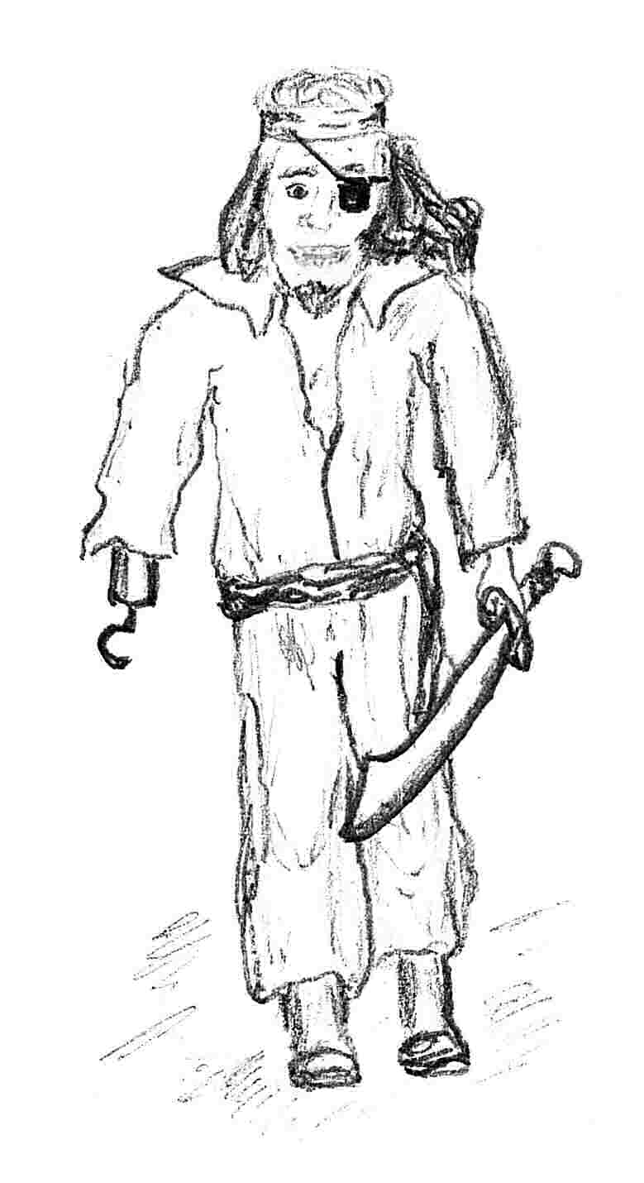 | Xcercses  First mate  Flag bearer | 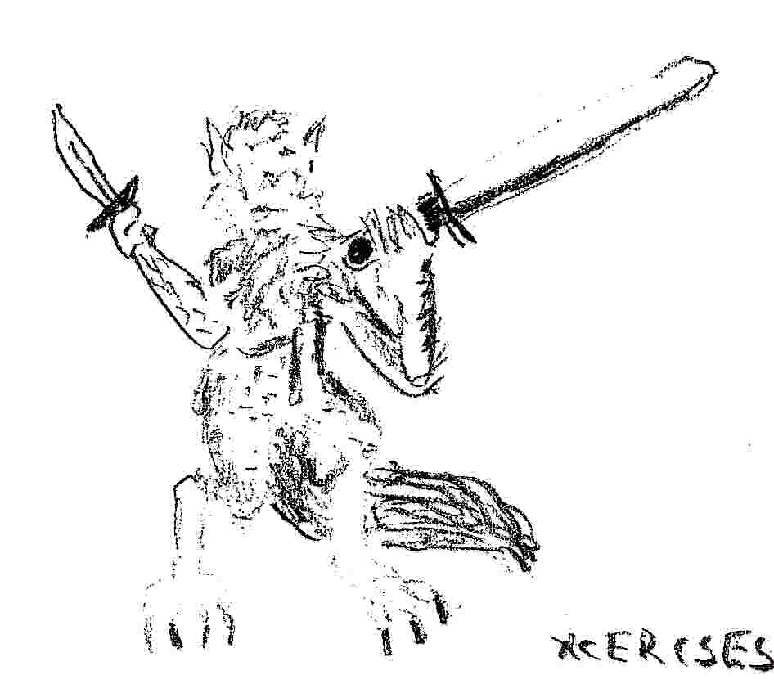
Jonn  Quartermaster  Flag bearer | 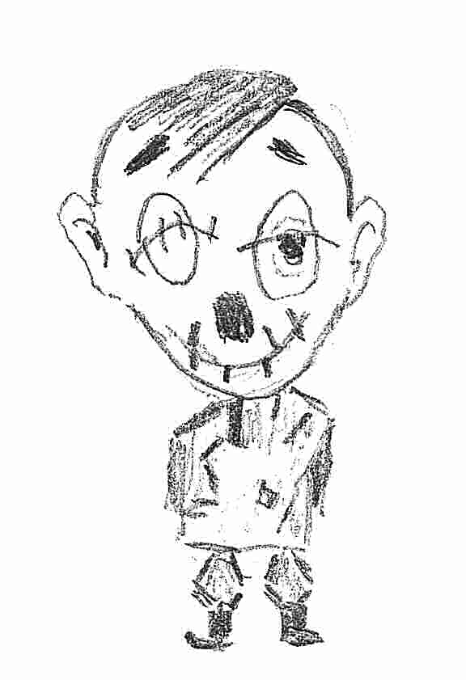 | Gremlin  Bosun  Galley crew  Flag bearer | 
Jester  Flag bearer | 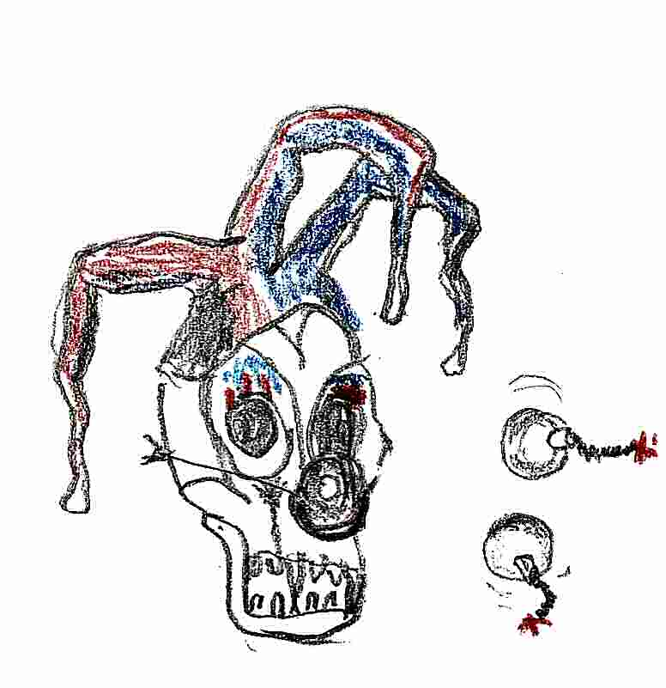 | Keith Moon  Boatswain or bosun  Flag bearer | 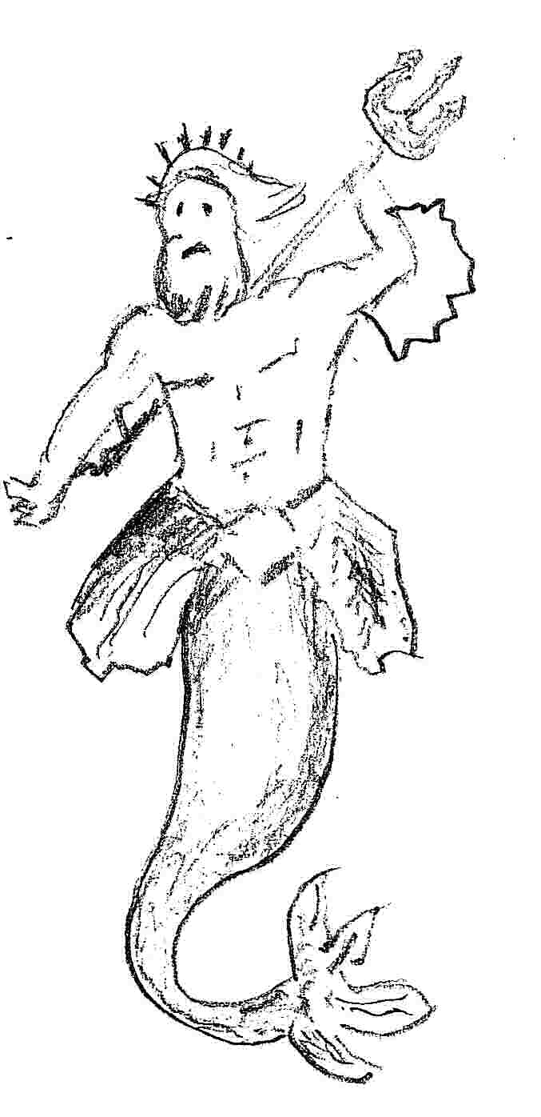

Bootes  Navigator  Flag bearer | 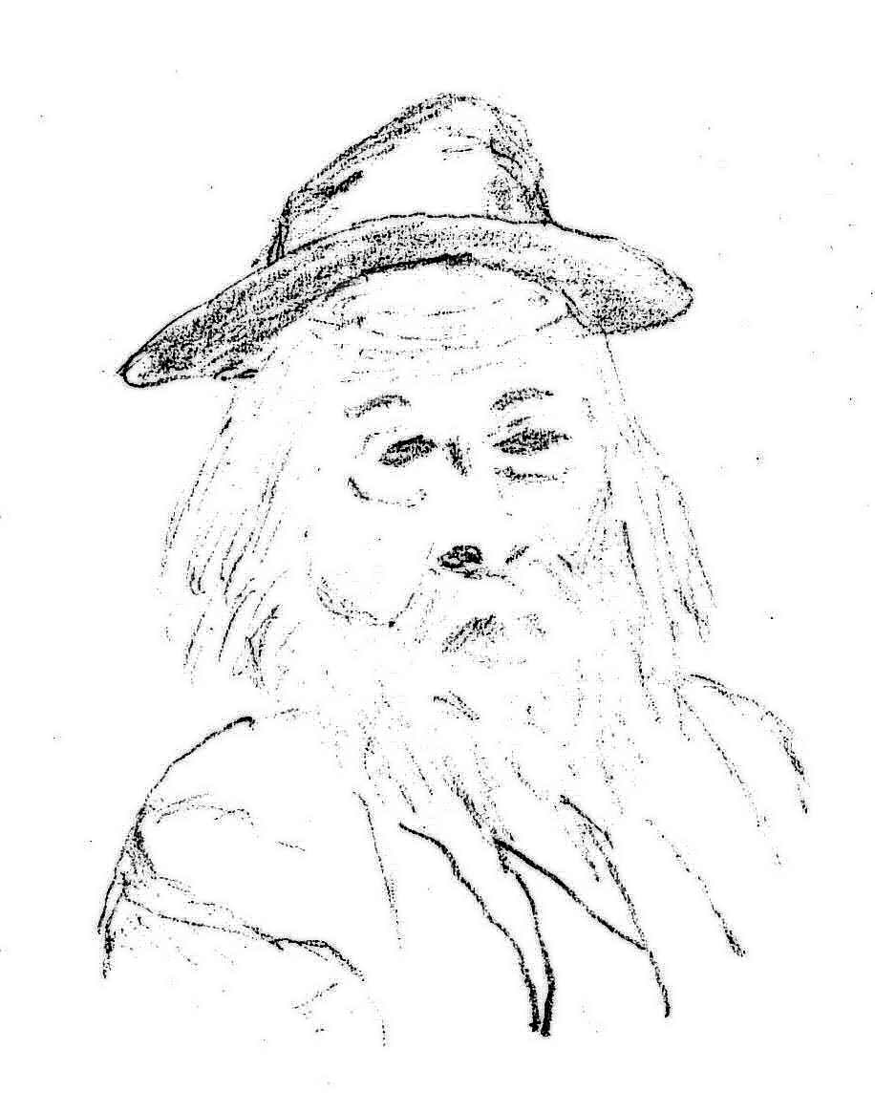 | Innocence  Flag bearer  Intangible said to be seen as an pale shimmering sparking in an sun ray | 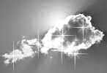
Amoran K Kol  Flag bearer | 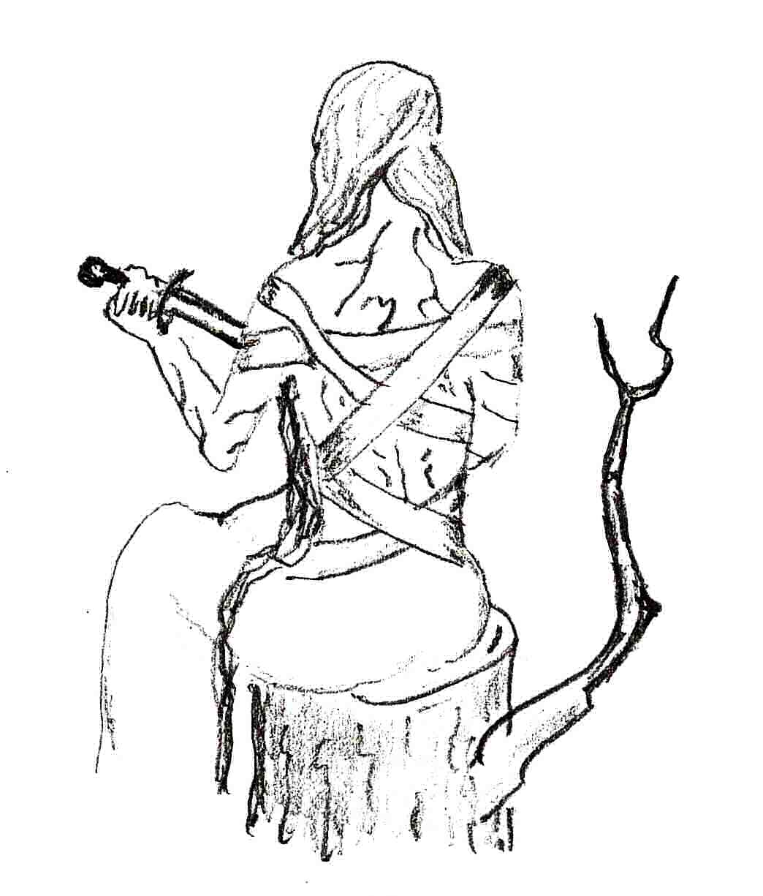 | Adiallinda  First mate  Flag bearer  An red head  She as an pirate coffer | 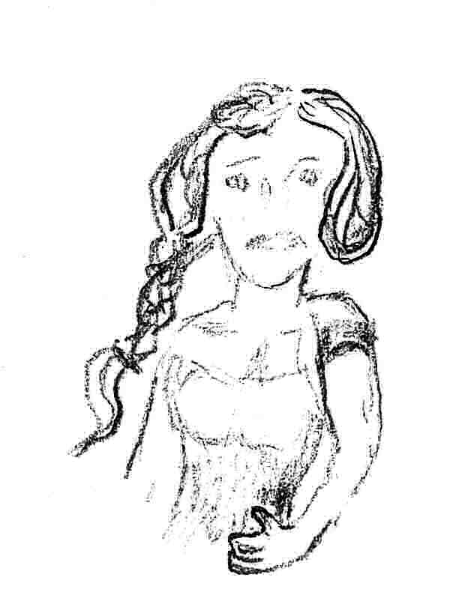
Assurancetourix  Flag bearer  Shapeshifter |  | Czez  Flag bearer | 

Silver Renard  Flag bearer  Shapeshifter | 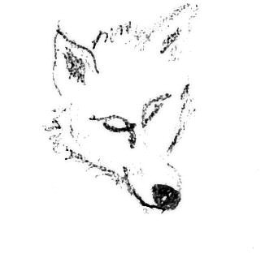 | Ailith | 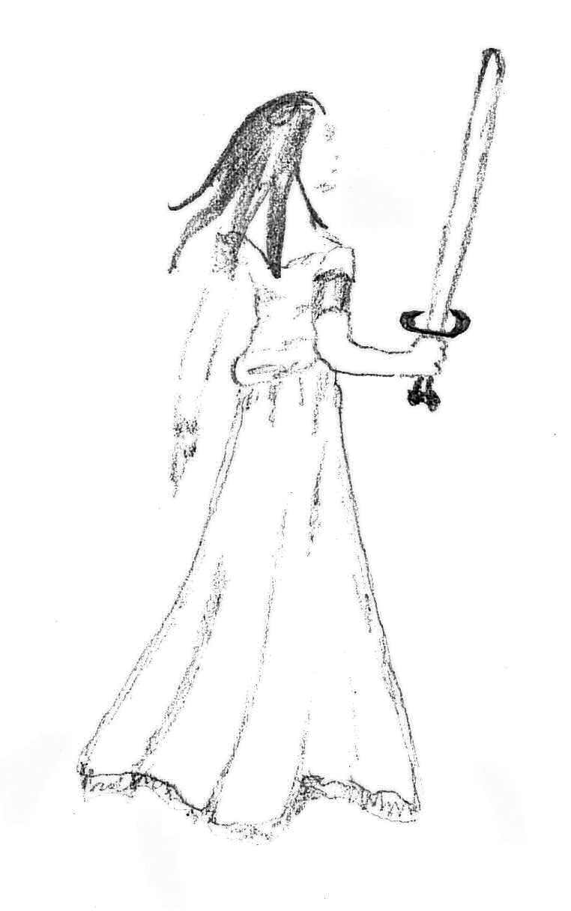
Virtuous Pride  Shoulder hight hairs, his plants knowledge make him an kind of druid | 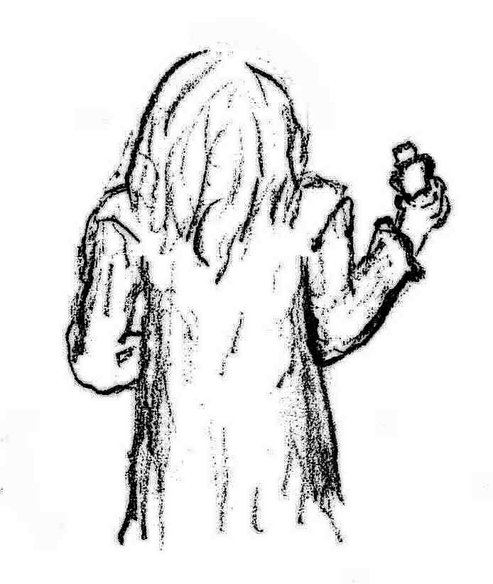 | Cutler  Strategist | 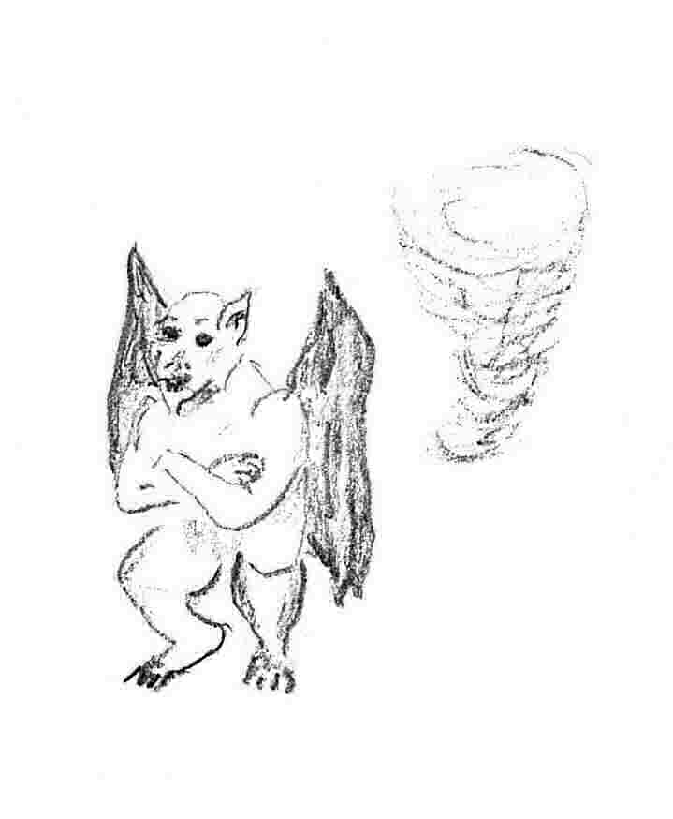

Notes:
- Crew drawings where made from according to there availability
  - Know game avatar
  - Know forum avatar
  - Webcam picture
  - Rememberance of old avatar descriptions
  - Or just making up an avatar that seem to fit the character description
- The Storm Coast location not being available, the boat subject was chosen as an kind of boat that would have made an pirate joy
- Some positions are indicate to more than one crew, as it as change true time to time

